Protocol of Pairing as a Capacity Building Activity

Work Package 6 - EUnetCCC

Index

1. PRE-READS 3
PURPOSE OF THE DOCUMENT 3
THE CAPACITY BUILDING SYSTEM 3
DEFINITIONS 4
LIST OF DOMAINS AND ASSIGNED CCC COORDINATORS 5
2. PAIRING PROGRAMME 5
DEFINITION 5
CONTEXT OF PAIRING WITHIN CAPACITY BUILDING FOR CERTIFICATION 5
PARTICIPANT SELECTION FOR PAIRING 6
3. PLANNING & RESOURCING 7
MAIN ROLES AND RESPONSIBILITIES 7
RESOURCES PROVIDED 7
PROFESSIONAL PROFILES OF PARTICIPANTS 8
4. METHODOLOGY 8
PHASE 1. ENGAGEMENT AND JOINT PLANNING 11
PHASE 2. IMPLEMENTATION AND MONITORING 11
PHASE 3. CONSOLIDATION & CLOSURE 14
5. EVALUATION AND CONSOLIDATION OF THE PAIRING PROGRAMME 16
6. EXPECTED OUTCOMES 16

PRE-READS

PURPOSE OF THE DOCUMENT
This document provides a detailed protocol for implementing the WP6 Pairing Programme and serves as a practical reference primarily for CCC Coordinators. It clarifies the scope, roles and key steps, as well as the expected deliverables and monitoring to support consistent delivery. While intentionally detailed, it is designed as a set of implementation keys and will be adapted as needed once concrete matchings are confirmed, to reflect centres’ contexts and priorities.

THE CAPACITY BUILDING SYSTEM
The Capacity-Building approach developed within the EUnetCCC JA follows an integrated model combining personalised support, peer-to-peer exchange, and structured tools. All activities—site visits, workshops, digital resources, and centre-to-centre support—are tailored to the specific needs of Aspiring centres, as identified through common diagnostic instruments such as the Maturity Model and Readiness Checklist (both defined in the following section).
The objective with the system is to strengthen institutional capacities and support progress toward EUCCC certification by promoting the adoption of standards. This modular approach blends thematic sessions, guidance, and collective learning, while ensuring continuous quality improvement’ monitoring and the integration of best practices across the network (Figure 1).
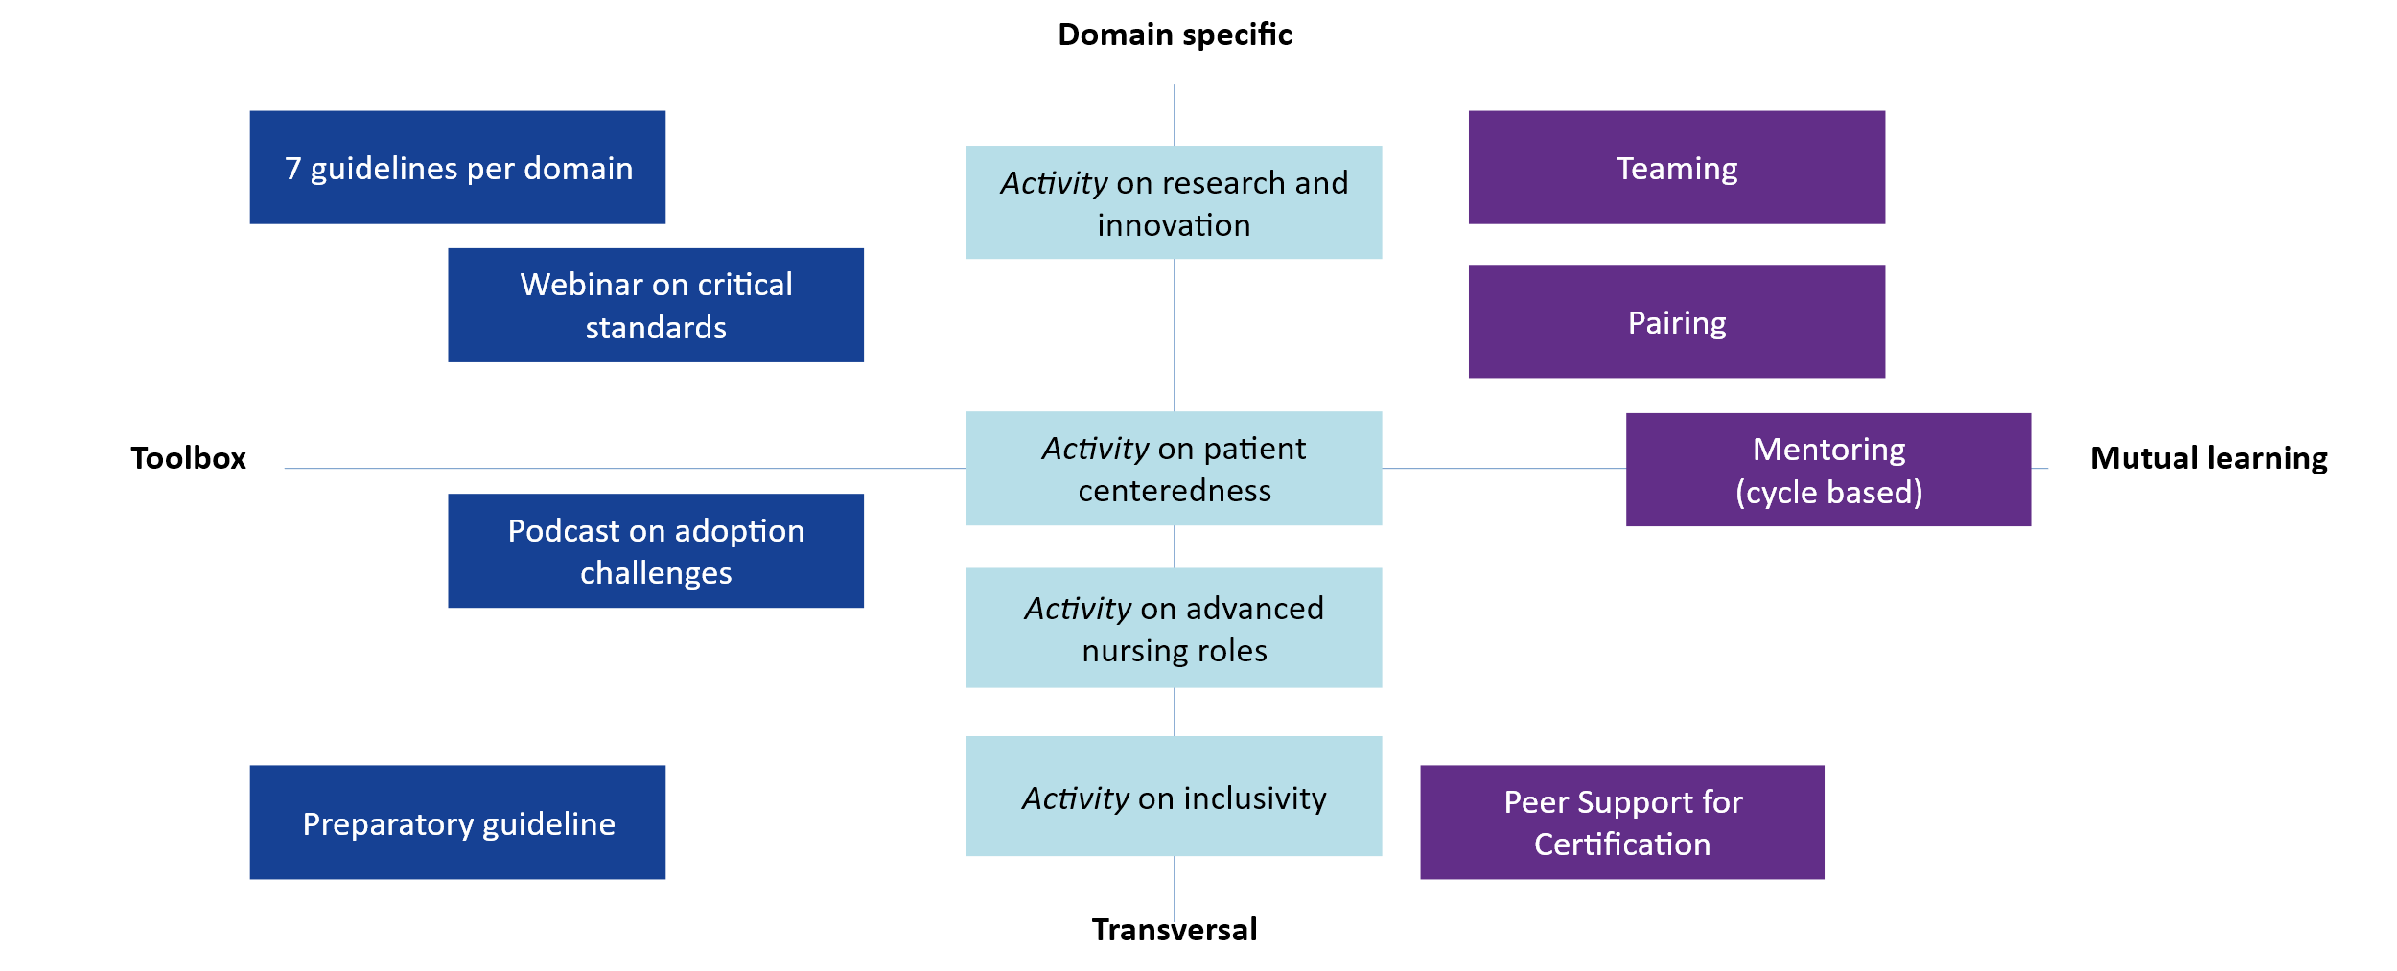

Figure 1. Capacity Building activities

DEFINITIONS
Capacity Building Group (CBG): Representatives of WP6 providing a liaison between Aspiring CCCs and CCC Coordinators to ensure communication and development of activities during the programme.
Facilitator of the CBG: Representative of the CBG supporting the overall pairing experience (e.g., optimising collaboration, attending the onsite visit), from diagnostic to closure. Operational arm of the CBG, it aims as supporting the CCC Coordinators in providing support to the overall process.
CCC Coordinators: Certified Comprehensive Cancer Centres designated as reference institutions for one of the seven EUCCC domains. They act as both content experts and leaders of peer learning within the capacity-building system.
Aspiring CCC: Centres with Pilot or Designated Candidate status willing to pursue the EUCCC certification from countries with no CCCs or CCs.
Paired Centres: A structured group of one CCC Coordinator and one Aspiring CCC working towards the coordinated implementation of a specific domain of the EUnetCCC Standards and its integration within the overall Set of Standards (SoS).
Preparatory Kit: set of documents and tools that will be made available to Pilots and Designated Candidates to EUCCC certification. It contains the following items:
- Preparatory Guideline for Candidate CCCs: A practical resource for centres aspiring to achieve CCC certification. The guideline outlines the preparatory steps and key considerations, helping centres to anticipate requirements and align their structures and processes accordingly.
- Readiness Assessment Checklist (RACCC-31): A 31-item online questionnaire helping Aspiring CCCs assess their level of readiness, focusing on centres’ baseline capacities and capabilities as well as their framework conditions.
- List of Essential Care and Research Infrastructures: A reference document that specifies the key units, facilities, technologies, and support systems that should be available (in-house and/or through access agreements) to deliver high-quality cancer care and research.
Maturity Model Webtool: Tool supporting CCC Participants in evaluating their organisational capacity and progress in alignment with the EUCCC Standards. It helps the Aspiring CCC and CBG to identify strengths, gaps, and priorities for targeted capacity-building interventions, while showing a path for Standard implementation.
7-Domain Guideline: A resource document which reorganises into key steps to implement EUCCC standards across each of the seven domains. Developed through expert knowledge-generation workshops with CCC Coordinators, this living document will be fed with concrete experiences, recommendations and examples from peer learning activities such as Pairing.
Quality Improvement Indicators: QIIs translate key EUCCC standards into measurable processes and outcomes across seven domains, enabling continuous quality improvement by tracking progress, identifying gaps, and guiding action. By assessing them at baseline and key milestones, centres can visualise change over time and strengthen a learning culture that maintains high standards beyond initial certification.

LIST OF DOMAINS AND ASSIGNED CCC COORDINATORS
Domain of EUCCC Standards | CCC Coordinators
Governance | Candiolo Cancer Institute, Italy |  | Oslo University Hospital, Norway
Care | Institut de Cancérologie de l'Ouest, France |  | CCC Niedersachsen, Germany
Research | Vall d’Hebron Instituto de Oncología, Spain | WTZ Essen-Münster, Germany |  | Institut Gustave Roussy, France
Integration of Research and Care | INT Milano and AUSL Reggio Emilia, Italy |  | IPO Porto, Portugal
Innovation | Institut Català d’Oncologia, Spain |  | Institut Curie, France
Prevention | Centre Léon Bérard, France |  | Lillebaelt Hospital, Denmark
Education and Training | Medical University of Vienna, Austria
Table 1. List of EUCCC domains and assigned CCC Coordinators

PAIRING PROGRAMME

DEFINITION
The Pairing programme is a peer-learning capacity-building activity, designed to provide one-on-one (1:1) support and guidance for an Aspiring centre, from a country without CC or CCC, focusing on a specific domain of the EUCCC Set of Standards. It aims to strengthen institutional capacity, foster local expertise, and develop practical implementation solutions enabling Aspiring centres to achieve measurable progress towards compliance and readiness for certification, through mentorship, feedback mechanisms, and monitoring by the CBG.

CONTEXT OF PAIRING WITHIN CAPACITY BUILDING FOR CERTIFICATION
Pairing represents the most intensive capacity-building programme under WP6. It is strictly based on a one-to-one (1:1) relationship between a CCC Coordinator and a Participant centre.
Centres involved in Pairing are not eligible to participate simultaneously in the Teaming programme.
As CCC Coordinators are responsible managing both Pairing and Teaming, optimisation of their role is foreseen, including shared feedback mechanism and common resources.
Participants engaged in Pairing may receive, in parallel, additional thematic support based on their specific needs through activities such as Innovation & Research Activity, Patient Centredness, Advanced Nursing Roles, Precision Oncology Education and Palliative Care (together with the NoE on Palliative Care in the Joint Action JANE-2). Also, they can participate at any time in relevant EUnetCCC Network activities (WP8).

PARTICIPANT SELECTION FOR PAIRING
- Pairing is intended for Aspiring CCCs that will pursue EUCCC Certification in European health systems without an existing CC or CCC in their country.

- The selection and pairing process considers factors such as maturity in the EUCCC domain, CCC configuration and geographic or institutional similarities with the assigned CCC Coordinator.

- Up to 14 Aspiring centres will participate in the Pairing programme, each matched with one CCC Coordinator.

- Expressions of Interest (EoI) from Aspiring CCCs may be submitted until April 1st, 2026. Matching of Pairs will be proposed by the CBG (recipient of the EoI) to the CCC Coordinators following receipt of the EoI.

- The CBG will throughout the programme actively manage Aspiring CCC’s lack of engagement or other red flags during implementation.

PLANNING & RESOURCING

MAIN ROLES AND RESPONSIBILITIES
CCC Coordinators:
- Provide tailored, domain-specific guidance and mentorship.
- Inspire and support local change processes within the Aspiring centre based on empathy and common understanding.
- Facilitate structured interaction, site visits, and implementation planning.
- Participate in continuous feedback and monitoring with the CBG.
Aspiring Centres:
- Commitment to the Pairing process, maintaining open communication and collaboration.
- Implement improvement actions aligned with the EUCCC Standards.
- Conduct self-assessments using the Maturity Model Webtool.
- Share results and progress updates with both the CCC Coordinator and CBG.
- Select QIIs to work on, provided by the CBG, to measure local impact on quality and document the effects of Capacity Building Support
Capacity-building Group (CBG):
- Oversee coordination, logistics, and alignment of all Pairing activities.
- Provide shared tools (e.g., agenda and report templates, visit timelines, documentation).
- Facilitate monitoring of aspiring CCCs’ progress and manage feedback loops in case of a lack of progress.
- Serve as a permanent liaison between CCC Coordinators and Aspiring centres.

RESOURCES PROVIDED
For CCC Coordinators:
- Guidance and templates for structuring Pairing activities and visits.
- Budgetary support for on-site exchanges.
- Access to aggregated feedback and progress reports from the CBG.
For Aspiring Centres:
- Access to the Maturity Model Webtool and Readiness Assessment Checklist (RACCC-31) for needs’ analysis and continuous monitoring.
- Partnering Gap Analysis to identify development priorities.
- Reporting templates and coordination support.

PROFESSIONAL PROFILES OF PARTICIPANTS
The teams from the paired centres that are expected to participate in the meetings and exchanges should ‘mirror’ each other. For example, in Pairing activities focusing on the prevention domain, a clinical specialist responsible for this area should participate both from the CCC Coordinator’s side and from the Aspiring CCC’s side.
This said, the typical participants expected are:
- 2-3 physicians specialised on the domain
- 1-2 healthcare professionals (psycho-oncologists, nurses…)
- Certification leaders, quality managers or roles that can facilitate implementation of standards (Organisation of services, IT and data related support)

METHODOLOGY
Key principles governing all Pairing programs
Pairing promotes peer-to-peer knowledge exchange while respecting the autonomy of Aspiring centres and Coordinators and allowing adaptation to local context and needs. The overall should be based on effective solutions to the implementation challenges posed by the EUCCC SoS, including potential obstacles and barriers.
In this context, a significant effort should be made to contextualise the starting conditions of each participant when considering their:
- Level of readiness, including the infrastructures in place
- Level of maturity with regards to the Domain of the Standards being approached
- General results of the Maturity Model, describing the overall gap with regards to the whole SoS.
While the Aspiring centres should clarify their starting conditions that will be shared with CCC Coordinator, the CCC Coordinator should be clear and honest about the inherent difficulties related to the Domain as well as supportive, respectful and creative on local options.
Institutions are not paired themselves, but a team of healthcare professionals from each side. Empathy, mutual rapport and common understanding is as important as the provision of expert knowledge on how to implement the Standards. Such a double level characterising the Pairing programme —communication and expert guidance— is shown in the following figure (Figure 2).
The Pairing programme can be a source of good practices and key learnings. WP6, in agreement with the CCC Coordinators and Aspiring CCCs, will capitalise on the knowledge and experiences generated to incorporate them into the 7 Domain guidelines and produce webinars, podcasts or other multimedia resources.

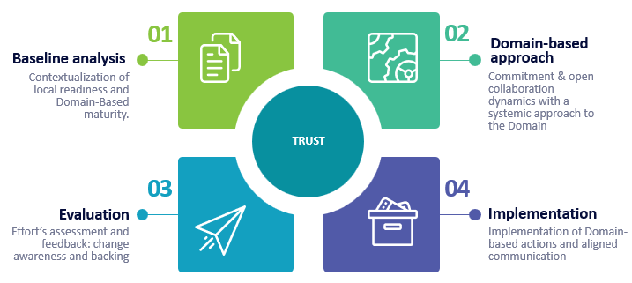

Figure 2. Overall Methodology Cycle
Pairing 1 CCC Coordinator to 1 Aspiring Centre: how it will work in practice
In practical terms, once Aspiring Centres have completed their baseline conditions diagnostic (through the RACCC-31 and the Maturity Model tools), the CBG organises a matching process to assign each Participant to an appropriate CCC Coordinator (see PARTICIPANT SELECTION FOR PAIRING).
The CCC Coordinators then validate the pairing proposal and once confirmed, the CBG formalises the Paired centres and communicates its creation to all participants, providing them with initial coordination tools and a provisional timeline. To organise the Pairing programme, the Aspiring CCCs must fulfil an ad-hoc template with contact people for all relevant departments that will be engaged related to the selected EUCCC domain (Figure 3).
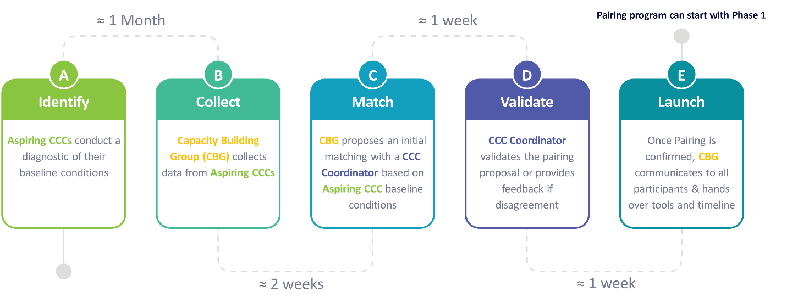

Figure 3. Process of Pairing CCC Coordinators and Aspiring Centres
Pairing in practice: suggested timeline and phases
The Pairing programme implementation includes three phases encompassing 18 months (summarised in Table 2). The timeline is provided for indicative purposes only and will be adapted in real conditions when matching Aspiring CCCs with CCC Coordinators.

Table 2. Pairing programme implementation timeline (18 months)
Phase | Timing (Month) | Responsibilities
Phase 1. Engagement & Joined Planning |  | CBG | CCC Coordinators | Aspiring centre
Online onboarding | 0-2 | Broker communication and ensure objectives alignment  Provide structure and support documents: slides template for the Aspiring Centre’s presentation, set up of the online meeting. | Assess the result of the gap-analysis based on readiness assessment, maturity and availability of infrastructures presented by the Aspiring Centre | Share readiness results and Maturity scoring data.  Present institutional context and domain-based challenges
First On-site Visit  (Hosted by the CCC Coordinator) | 3 | Attendance at the meeting and ensure the agenda covers programme objectives  Capture outputs and good practices for WP6 tracking | Host the on-site visit (1.5 days)  Share good practices and domain insights  Co-develop a preliminary roadmap  Agree to the Memorandum of Understanding (MoU) | Present a needs analysis synthesis.  Draft roadmap objectives  Commit to actions to be implemented (MoU), including selection of QII to be monitored in phase 2
Phase 2. Implementation and Monitoring |  | CBG | CCC Coordinators | Aspiring centre
Implementation period | 4-11 | Monitor roadmap progress and communicate results to the CCC Coordinators | Provide online guidance in case of major bottlenecks encountered by the Aspiring centre | Implement the roadmap and provide feedback to the CBG
Mid-Term Monitoring (Online) | 12 | Organise online checkpoint and document progress | Review progress and refine roadmap | Present progress and update maturity tool
Phase 3. Consolidation & Closure |  | CBG | CCC Coordinators | Aspiring Centre
Consolidation Workshop  (Hosted by the Aspiring centre) | 16 | Ensure objectives and sustainability planning are addressed  Document commitments and outputs | Assess implemented practices on-site.  Guide roadmap refinement and sustainability planning | Host the visit (1-day)  Engage in sustainability planning and update roadmap
Final Follow-up & Closure (Online) | 18 | Organise closing session and drafts final report | Reflect on lessons learned and potential future collaboration | Present final updates and feedback

PHASE 1. ENGAGEMENT AND JOINT PLANNING

ONLINE ONBOARDING [MONTH 0-2]

Objective
To define the foundation for tailored capacity-building support through establishing a shared understanding between the CCC Coordinator and the Aspiring CCC. Overall institutional context, internal capacities, and adoption challenges related to the domain should be clarified.

Activities
A two-hour virtual meeting between the CCC Coordinator and the Pairing Participant is organised by the CBG. The session begins with the Aspiring CCC presenting their institutional context using the RACCC31 and maturity data across all domains. This is followed by a structured review of their situation, guided by the targets and benchmarks of the 7Domain Guideline, with particular attention to any barriers to accessing the resources needed to meet domain-specific standards. The meeting concludes with agreement on the QIIs to be measured for the domain.
The CCC Coordinator can therefore provide first feedback and assess the initial gap analysis, identifying challenges and possible learning synergies. The session concludes with a preliminary discussion of expected outcomes and focus areas for the on-site visit.
The CBG ensures that the session is structured and documented, capturing all relevant information to guide the on-site visit. No overall presentations of the paired institutions should be conducted during the on-site, to ensure optimisation of professionals’ working time.
FIRST ONSITE VISIT AT CCC COORDINATOR SITE (1.5 days) [MONTH 3-4]

Objective
Transfer knowledge, share best practices, and co-develop actionable steps for capacity enhancement in Aspiring CCCs for one Domain and its connection with the whole EUCCC Set of Standards.

Activities
See Annex 1 for the proposed agenda
Day 1 | Participant context and gap logic (Half Day)
Institutional presentation and context setting (30 minutes)
The on-site visit begins with presenting a one-page synthesis by the Pairing Participant resulting from a domain-based needs analysis, that is, connecting the results of Maturity Model results and the 7-Domain Guideline key learnings with the local potential of change. The CCC Coordinator and the Facilitator of the CBG provide framing remarks, contributing to clarify the objectives of the day and situating the bilateral work within the broader capacity-building process. This session ensures a shared understanding of the Participant’s starting point and expectations for the two-day engagement.
Domain approach and integration with the whole Set of Standards (1.5 hours)
The Participant engages in a structured discussion with the CCC Coordinator to go over its most pressing challenges in adopting the EUCCC SoS. Using the pre-identified gaps and needs analysis as an anchor, the Coordinator facilitates exploration of governance, culture of quality, data use, and pathway-related issues potentially related to the Domain. Together, they validate 3–4 cross-cutting areas that will become the focus of the capacity-building efforts together with the domain specific issues. The CBG documents the discussion and ensures alignment with WP6 objectives.
Targeted problem-solving and exchange of practices (1.25 hours)
In this interactive working session, the CCC Coordinator presents tailored good practices and examples relevant to the Participant’s specific gaps on the Domain. The exchange is designed to move beyond description and towards practical adaptation, discussing feasibility, enablers, and barriers in the Participant’s context. The Pairing Participant is expected to reflect actively and propose how such practices could be translated into its institutional setting.
Day 1 synthesis and preparation for Day 2 (30 minutes)
The half-day concludes with a structured synthesis session led by the CCC Coordinator, with support from the Facilitator of the CBG. The discussion consolidates the key outputs from Activities 1–3, including: (i) the Participant’s main domain-specific gaps, (ii) 3–4 validated cross-cutting areas linked to the domain, and (iii) initial candidate solutions and enabling conditions. The session ends by agreeing what evidence, examples, or internal stakeholders should be brought into Day 2 discussions, and by defining the key questions that the roadmap should address. The CBG summarises the agreed focus points and documents them as inputs for Day 2 priority setting and roadmap development.
Day 2 | CCC Coordinator model and translation into an actionable plan (Full day)
Domain insights and priority setting (1.5 hours)
The day begins with a session led by the CCC Coordinator presenting their strategic approach to the selected domain, including governance structures, organisational models, and processes underpinning successful implementation of the EUnetCCC standards. Building directly on Day 1 outputs, the session then shifts to a structured priority-setting exercise to confirm the Participant’s focus areas (domain-specific and cross-cutting, where relevant to the domain). The final part of the session is dedicated to drafting the Participant’s preliminary roadmap (“version 0”), capturing 2–3 short-term objectives with key actions, responsible actors, and initial milestones.
The Pairing Participant contributes by validating feasibility and ownership. The Facilitator of the CBG ensures alignment with WP6 objectives, captures key decisions, and documents the initial roadmap for use during the remainder of Day 2 and subsequent follow-up.
Flagship initiative presentation and site demonstration (3 hours total)
The morning continues with a 1.5-hour site tour and live demonstration, showcasing domain-specific workflows and tools such as patient pathways, multidisciplinary tumour boards, or IT dashboards, when appropriate. Participants observe operational excellence and can ask detailed questions.
After lunch, the CCC Coordinator leads a 1.5-hour deep dive into a flagship initiative central to standard implementation. This session explores objectives, methodologies, tools, KPIs, and lessons learned, providing a concrete example of translating strategy into practice. The Pairing Participant uses this opportunity to contrast observed practices with their roadmap draft, while Teaming Participants benchmark against their contexts.
Comparative reflections and open exchange (1 hour)
The day concludes with a 1-hour open exchange session where Participants present reflections on practices observed and discuss applicability to their settings. They share comparative insights on governance, resource allocation, and quality assurance challenges.
The Pairing Participant, building on their preliminary roadmap, can use this platform to test ideas. The CBG facilitates the session to ensure that both individual insights and collective lessons are captured, laying the groundwork for the follow-up phases.
Wrap-up and Next Steps (30 minutes)
The visit concludes with a 30-minute wrap-up session to agree on follow-up actions, timelines for monitoring progress, and preparations for the upcoming checkpoint and second visit. The CBG summarises commitments made and documents the outputs for tracking within the first checkpoint and future reference.
At the end of the first on-site visit, the CCC Coordinator and the Participant must sign a Memorandum of Understanding (MoU) confirming the agreed roadmap and next steps. This document will serve as a formal reference for implementation and monitoring during subsequent phases.

PHASE 2. IMPLEMENTATION AND MONITORING
IMPLEMENTATION PERIOD [MONTH 4-11]
After the meeting at the CCC Coordinator site, Aspiring Centres require sufficient time to implement the short‑term objectives outlined in the Roadmap formalised in the MoU and to plan subsequent actions. During this period, the CBG and the Aspiring CCC will remain in contact every three to four months to report on progress and discuss any emerging bottlenecks. If the Aspiring CCC encounters major barriers or significant deviations from the Roadmap established during the first onsite meeting, the CCC Coordinators will be informed and invited to an online mentoring session to revise the Roadmap accordingly.
MID-TERM MONITORING (ONLINE) [MONTH 12]

Objective
Assess the progress of Aspiring CCCs in implementing their short-term objectives and provide coordinated feedback to support ongoing improvement.

Activities
Approximately eight months after the first on-site visit, a structured online checkpoint meeting is held. The Aspiring CCC presents their progress, outlining actions completed, challenges encountered, and early outcomes based on the roadmap agreed.
The session includes a joint analysis using the Maturity Model to compare baseline versus status, reassess gaps, and refine implementation strategies. Based on the insights gathered, the CBG will send a report for the CCC Coordinators with the updates.
Outputs include a brief written summary of the Participant’s situation and updated short-term objectives and roadmap. CCC Coordinators will then write a response to the report and arrange an online meeting to discuss results and follow-up on their advances.

PHASE 3. CONSOLIDATION & CLOSURE
PAIRING CONSOLIDATION WORKSHOP [MONTH 16]

Objective

Review achievements in standards’ implementation, understand level of cross-Domain integration, and define sustainability plans. This phase implies a full-day visit of the CCC Coordinator to the Pairing Participant’s site.

Activities
The workshop is held at the Pairing Participant’s site. It is designed as an interactive, high-impact meeting to consolidate what has been achieved, discuss remaining challenges, and reinforce collaboration. See Annex 2 for the proposed agenda.
Welcome Session (30 minutes)
The day begins with a welcome session at the Aspiring CCC, where the CCC Coordinator and the CBG set out the agenda 2 weeks prior and objectives. This framing ensures that all participants share a common understanding of the purpose of the visit and how it builds on the previous engagement.

Presentation by Aspiring CCC (1 hour)
The Aspiring CCC provides a comprehensive update on progress since the initial visit. This presentation highlights key achievements, improvements implemented, and challenges that remain unresolved. The Coordinator and CBG provide feedback and facilitate discussion, drawing out lessons learned and areas requiring further support.
Joint site tour (1 hour)
A guided tour of the Aspiring CCC allows the Coordinator to observe practices that have been implemented or strengthened. This includes a focus on patient pathways, multidisciplinary tumour boards, and data management systems, when appropriate. The Coordinator uses the visit to assess the degree of alignment with EUnetCCC standards and to identify gaps or opportunities for improvement in real-world settings.
Thematic working session (1.5 hours)
The afternoon begins with a structured working session to analyse barriers and enablers encountered by the Participant during implementation. The Coordinator facilitates collaborative problem-solving, guiding the discussion toward sustainability planning. This includes identifying institutional supports, resource mobilisation, and cultural shifts required for durable improvements.
Roadmap refinement, wrap-up and next steps (1.5 hours)
Building on the thematic discussions, the Participant refines its roadmap with support from the Coordinator and CBG. This updated plan includes short- and mid-term objectives, clearly defined responsibilities, and measurable indicators for monitoring progress.
The visit concludes with a joint wrap-up session to consolidate sustainability strategies, agree on the next steps, and define the follow-up process. The CBG captures commitments made and ensures that outputs are aligned with WP6 monitoring and reporting requirements.
FINAL ONLINE FOLLOW-UP AND CLOSURE (ONLINE) [MONTH 18]

Objective
Review overall outcomes of the Pairing Activity, reflect on lessons learned, and ensure that final outputs are documented and integrated into broader WP6 resources.

Activities
A closing online session is held approximately two months after the second visit. The Participant briefly presents final updates and reflects on the value and limitations of the Pairing process. Coordinators offer their perspectives on group progress and future collaboration potential.
The CBG gathers feedback through a structured template and finalises documentation, including a summary of achievements, learning dynamics, and transferrable practices. This input will inform the WP6 knowledge base and support future capacity-building efforts.

EVALUATION AND CONSOLIDATION OF THE PAIRING PROGRAMME

Monitoring and Evaluation by the CBG
Assessment of the impact of the pairing activity on CCC Participants’ certification process wil be made using:
- Progress tracking through the Maturity Model web tool.
- Joint qualitative assessment with WP3 (Survey evaluation).
Integration of Lessons Learned
WP6 will collect feedback and outcomes to:
- Refine WP6 tools and methodologies, with particular emphasis on the adaptation of the 7-Domain Guideline document.
- Ensure transferability of good practices to candidate CCC or CCCs
- Integrate good practices and recommendations into MS44 and the final deliverable D6.5 (Final CB Guidelines).
Recognition
WP6 is explore the possibility of recognising participating CCC Coordinators with a "EUnetCCC Pairing Label" to acknowledge their contribution to the network’s capacity building.

EXPECTED OUTCOMES

- Increase Standard compliance of Participants in targeted domains
- Contribute directly to readiness for EUnetCCC Certification
- Foster mutual learning and stronger collaboration between CCCs
- Impact quality improvement areas identified by the Standards

ANNEX 1
PROPOSAL OF AN AGENDA FOR THE 1ST ON-SITE VISIT
Objective: Provide tailored, bilateral support to the Pairing Participant through a focused deep dive on institutional challenges, followed by integration into the joint Teaming agenda to benchmark practices, exchange knowledge, and define actionable roadmaps.
Day 1 (half day)
13:00 – 13:30 | Welcome and institutional presentation by Pairing Participant
13:30 – 15:00 | Deep dive into Participant-specific challenges and priority gaps
15:00 – 16:15 | Bilateral problem-solving session and exchange of targeted practices
16:15 – 16:45 | Day 1 synthesis and preparation for Day 2

Day 2
09:00 – 09:30 | Welcome and introductions
09:30 – 11:00 | Presentation by CCC Coordinator: overview of domain strategy and certification pathway
11:00 – 12:30 | Site tour: demonstration of key domain practices (e.g. multidisciplinary boards, digital tools, patient pathway management)
12:30 – 13:30 | Lunch
13:30 – 15:00 | Deep-dive session: flagship initiative and implementation journey
15:00 – 16:00 | Open exchange: Q&A, comparative reflections by Aspiring CCCs and roadmap refinement

ANNEX 2
PROPOSAL OF AN AGENDA FOR THE 2nd ON-SITE VISIT
Objective: Review progress since the first visit, observe implemented practices at the Aspiring CCC, jointly analyse barriers and enablers, and refine the roadmap to ensure sustainability and alignment with EUnetCCC standards.
09:00 – 09:30 | Welcome session: agenda setting and objectives
09:30 – 10:30 | Presentation by Aspiring CCC: progress, achievements, and challenges since first visit
10:30 – 11:30 | Joint site tour: observation of implemented practices, patient pathways, MDTs, and data systems
11:30 – 12:30 | Lunch and informal networking
12:30 – 14:00 | Thematic working session: collaborative analysis of barriers, enablers, and sustainability planning
14:00 – 15:00 | Roadmap refinement: updating objectives, responsibilities, and monitoring indicators
15:00 – 15:30 | Wrap-up and next steps: sustainability strategies, follow-up plan, and commitments

ANNEX 3 – TENTATIVE TIMELINES
